**What is static ?**

Static variables are those which do not depend upon the objects rather with the class itself

Sounds complex, but it is really a natural phenomena

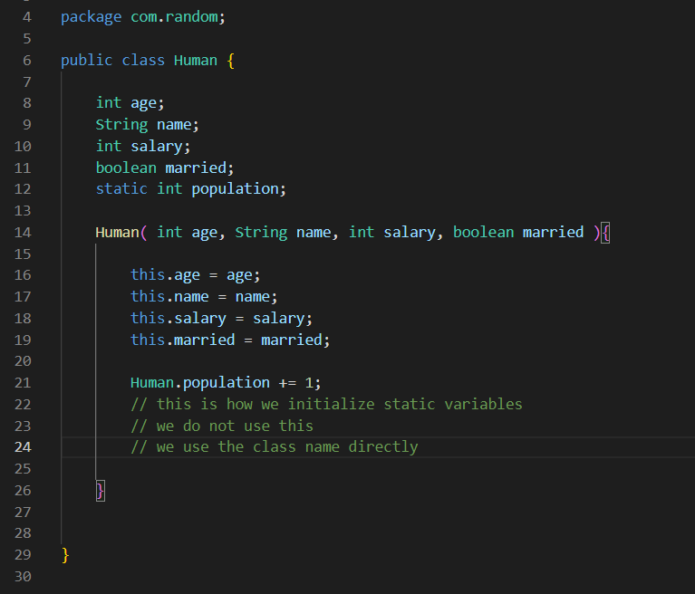

In this Human can there be a variable that is common for all the Human objects, for all the Human beings

The population

The population of the world is same for all the Human objects like “Amrit” “Aashish” “Ram” etc

It’s common sense that the population of the world won’t be different for different Human objects

So it is independent of the objects

Meaning the population depends upon the Human class itself

So the population is the static variable of the Human class



Static variables are same to all the objects created from the class, so they do not depend upon the objects

So they are dependent to the class itself

Also the static variables can be accessed by writing the class name not the object name



**We could also access the static variables via objects but the convention is to access using the Class name. Do not access via reference variable, use the class name**

Actually this may be depreciated later on

**We can not call an non static method from inside the static method without any reference variable to the object**

**But we can call any static function from inside any non static method**

Because every non static method belong to some instance variable, to some object

A static method does not depend upon object, than how can we call a method inside it that depend upon the object, just doesn’t make sense

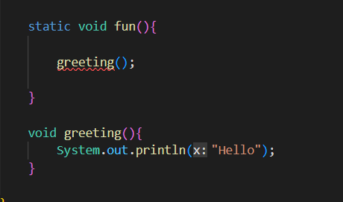

Here we have non static function call inside a static function

Static will be like, hay greeting( ) you are not static, then you must belong to any object, where is your reference variable ?

greeting( ) will be like I don’t have any reference variable

Than,

static be like

No no no, if you want to be called inside me make yourself static or get yourself a reference variable

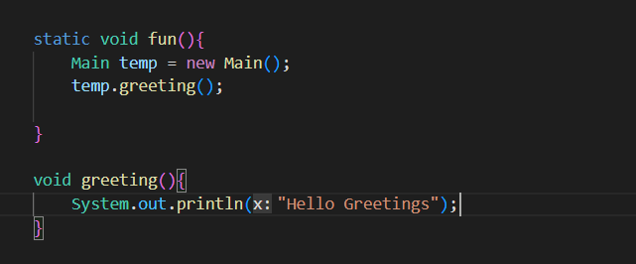

Now it is fine, since greeting has got a reference to an object

**Initialization of static variable**

Just like the constructor is a special method that gets called very first when object is created and initializes the variables for the object

Same way

To initialize the static variable, we have something called static block that static block will get executed exactly once when the class is very first loaded

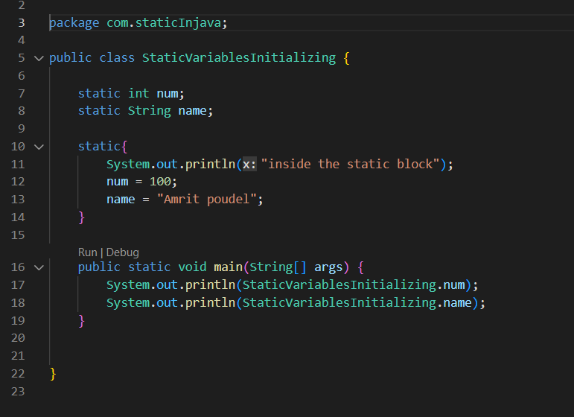

This is how we initialize the static variables

here static block is executed exactly once when the class is loaded

